**Obi Chioma Blessing**

[**Obi.chioma@womentechsters.org**](mailto:Obi.chioma@womentechsters.org)

**WT/21/173**

**PRACTICAL ACTIVITY 3: ON LINUX SYSTEM ADMINSTRATION**

**Part 1: of Practical Activity Week 3**

1. **List the processes for the current shell.**

The command **top** and **htop** is used to display the process for the current shell.

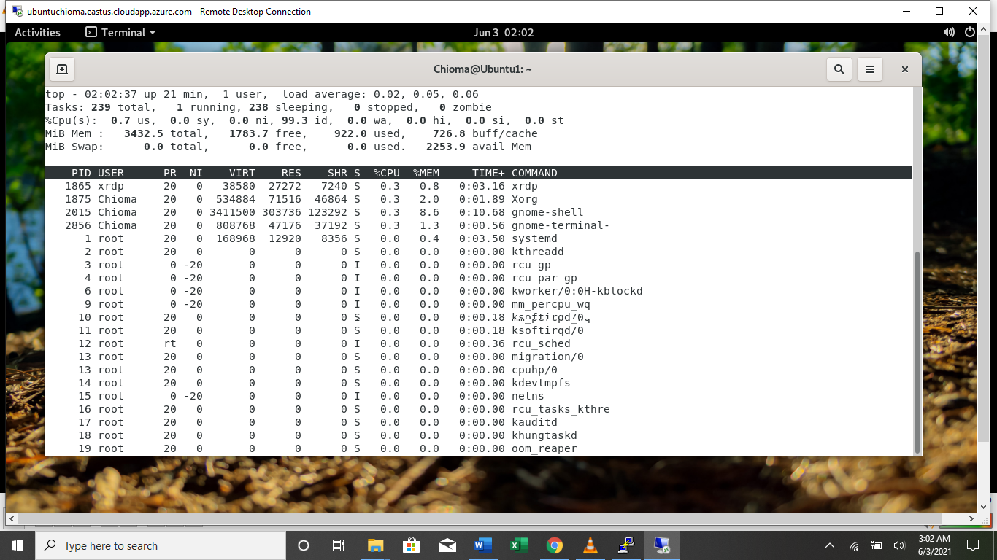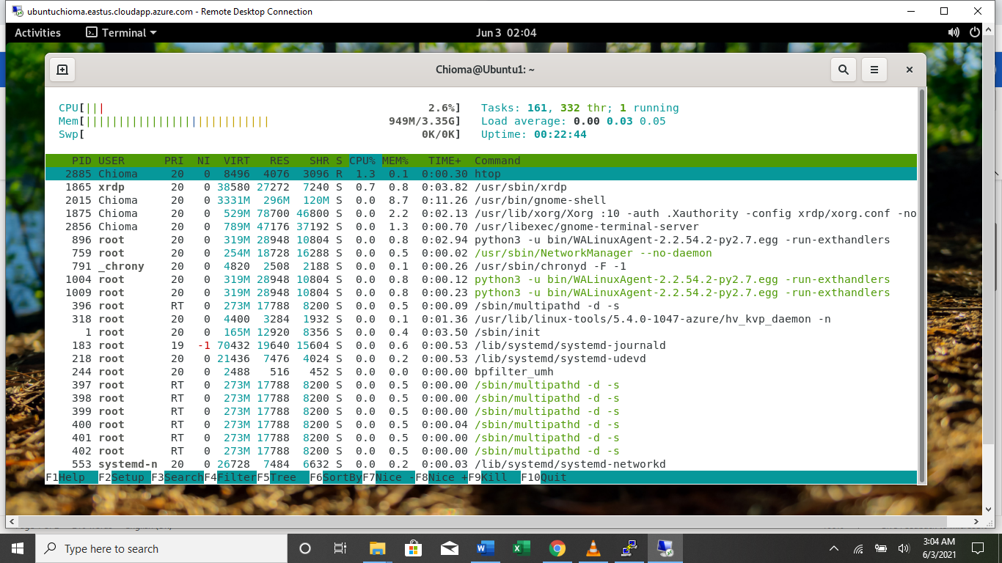

1. **Display information about processes.**

To show information about the process, I use the command **ps aux** ; where **a**  prints the running processes from all users, **u** shows user or owner column in output and **x** prints the processes those have not been executed from the terminal.

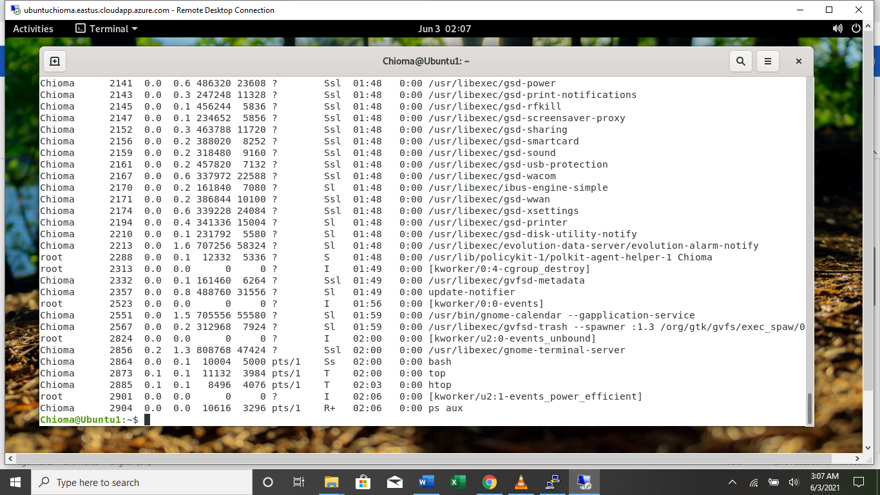

1. **Display the global priority of a process and find out the column that provides.**

**ps –ecl** displays the global priority of the process. From the PRI column, it is shown that khugepaged has the lowest priority whilemigration/0 ang watchdogd has the highrst priority.

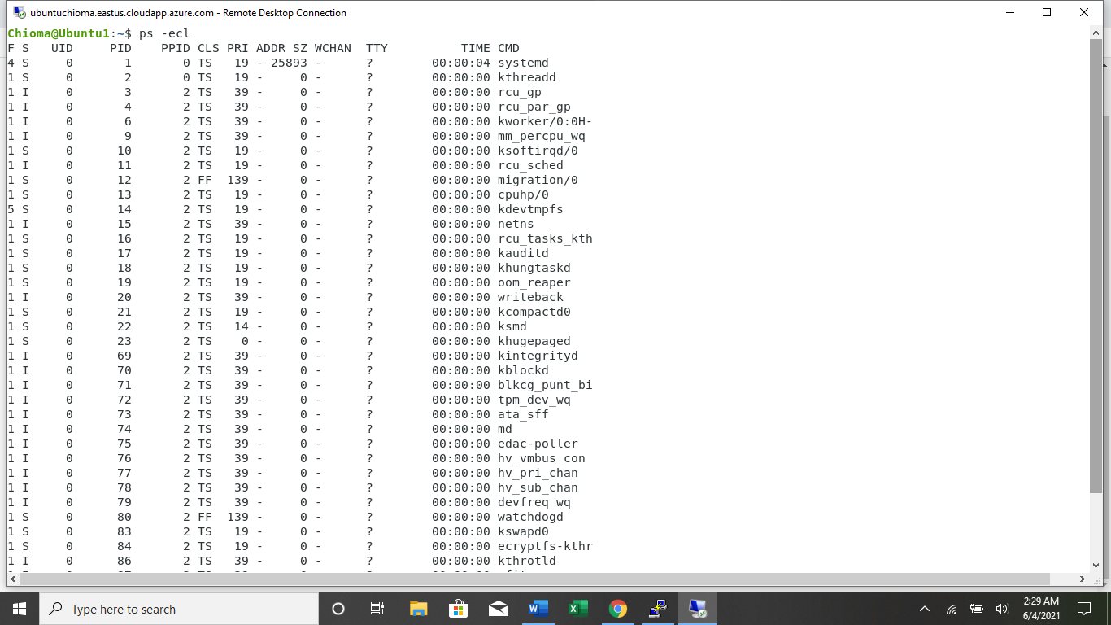

1. **Change the priority of a process with default arguments.**

Using the command **sudo renice 20 1041** changed the priority from 20 to 19 qith the same process ID of 1041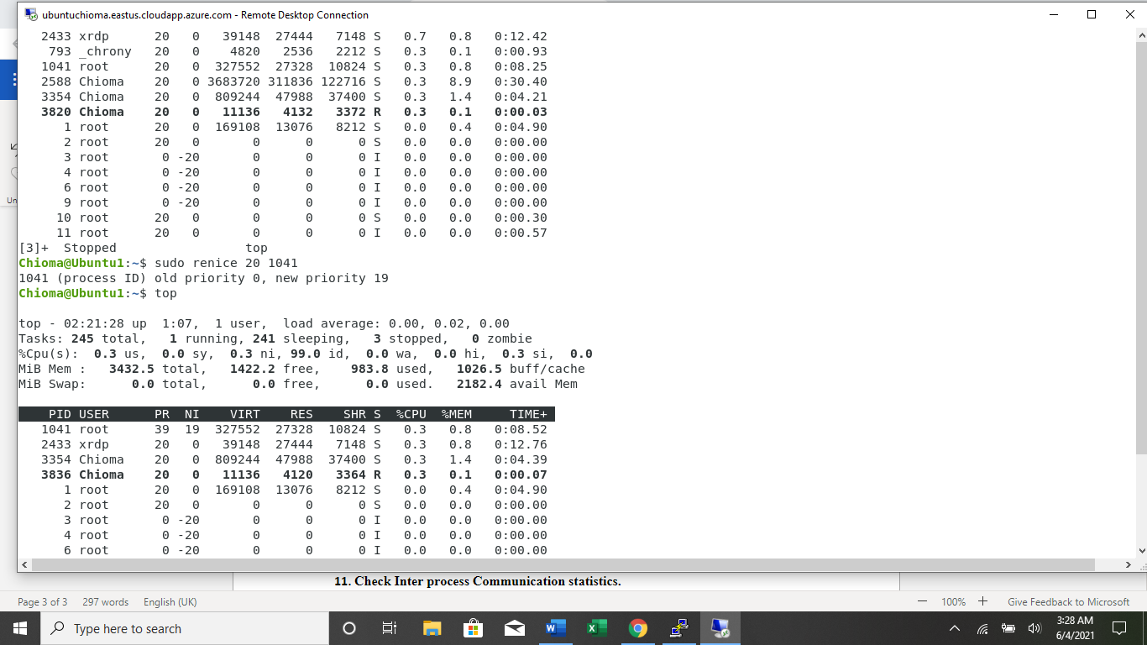

1. **Display Virtual Memory Statistics.**

The command **vmstat**  shows the virtual memory statistics.

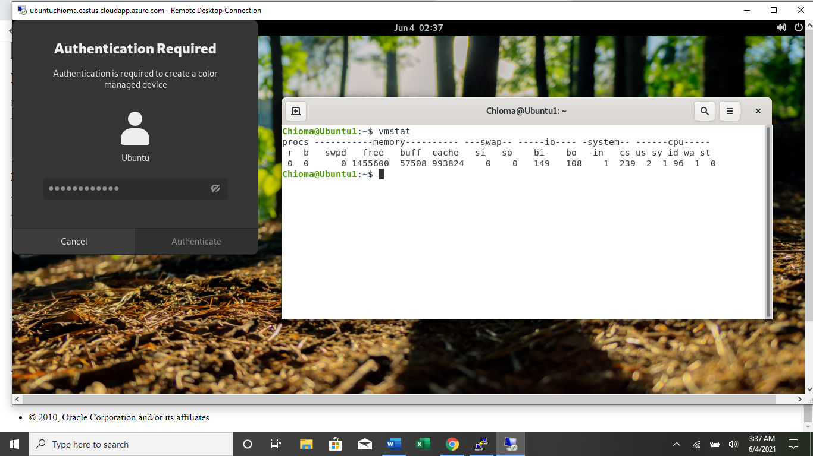

1. **Display System Event Information.**

The command **vmstat –s**  is used to display the system event information

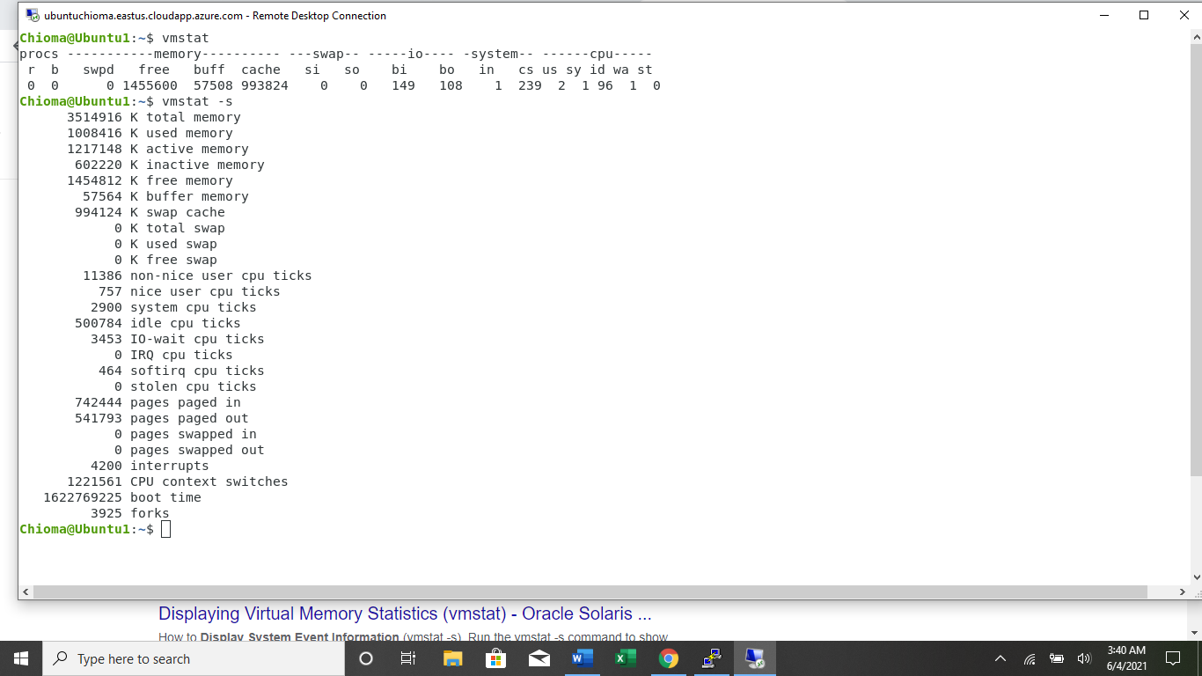

1. **Display Swapping Statistics.**

Using the command vmstat –S to display swapping statistics.

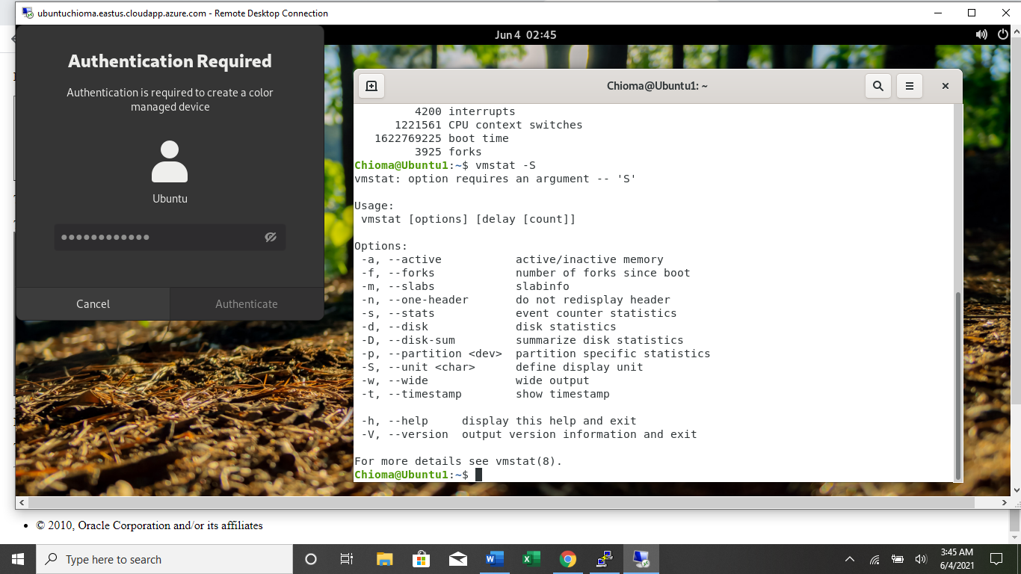

1. **Check File Access statistics.**

To check the file access statistics, I created a file called Chioma.txt in the Desktop directoy and used the command **stat Chioma.txt** to check the access statistics.

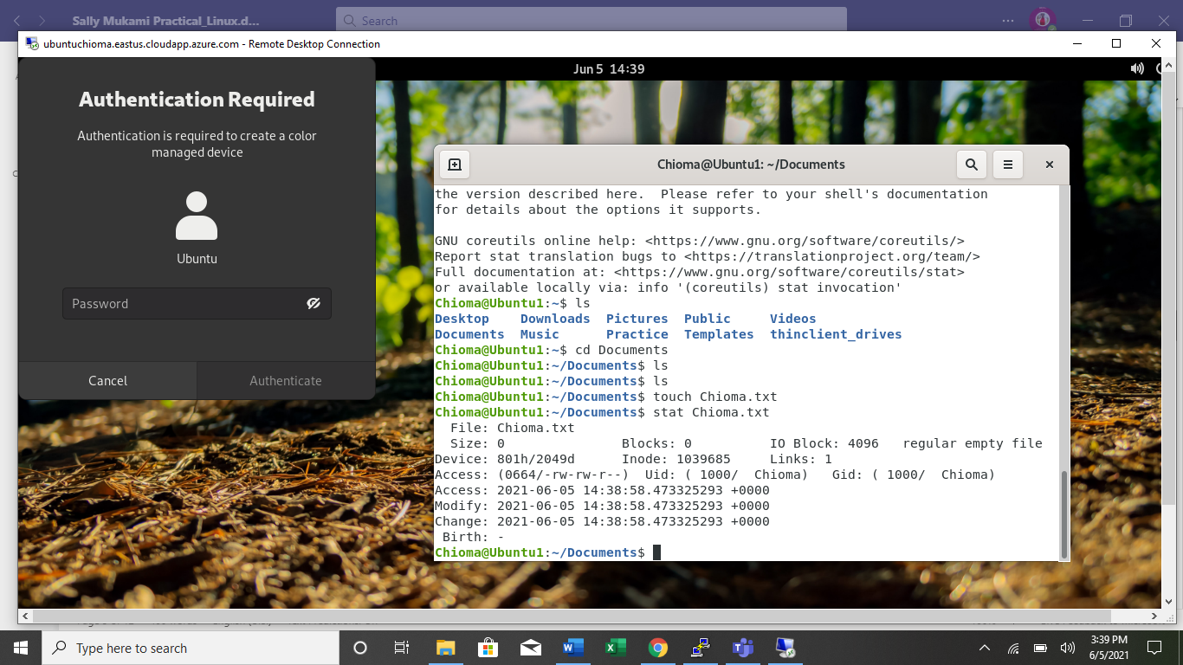

1. **Check Buffer Activity statistics.**

I installed sysstat, then opened a default file using **vim /etc/default/sysstat**  to change the settings from false to true. Then used **sar –b** to check the buffer activity statistics.

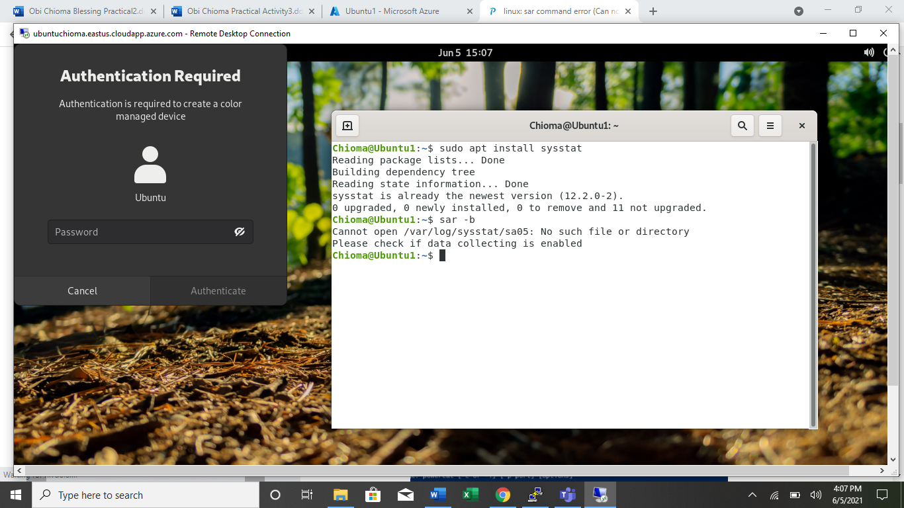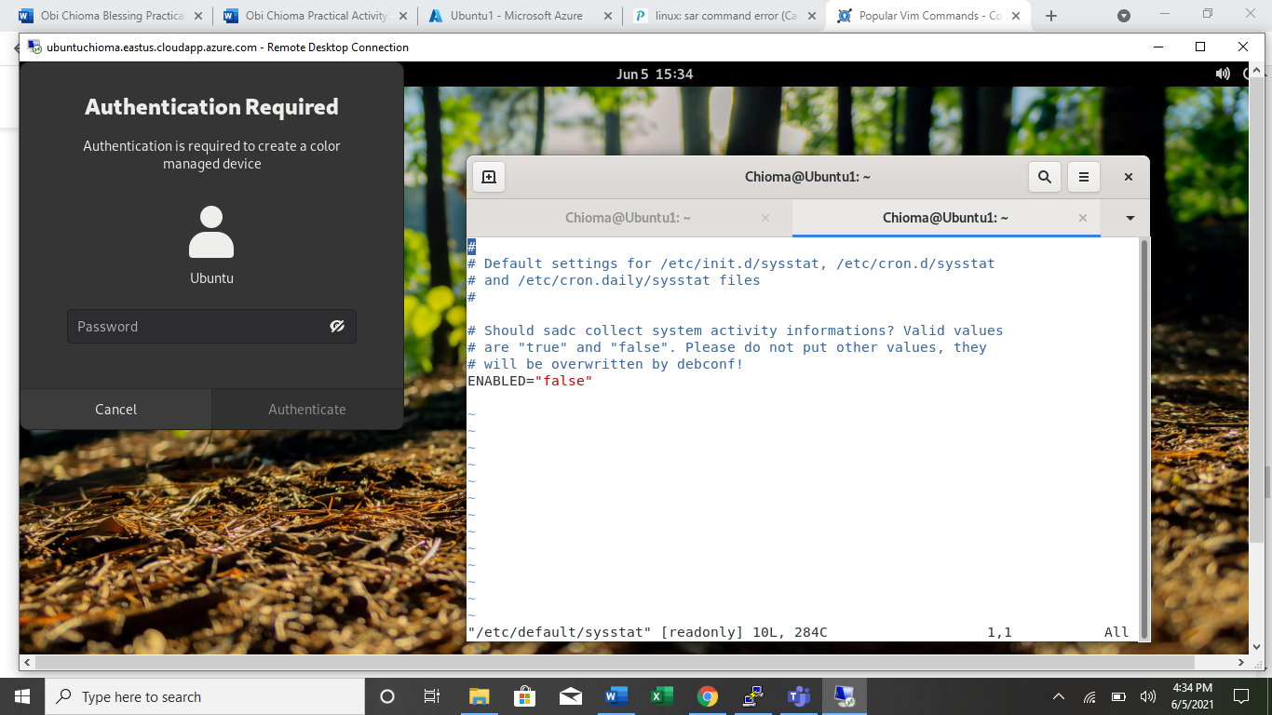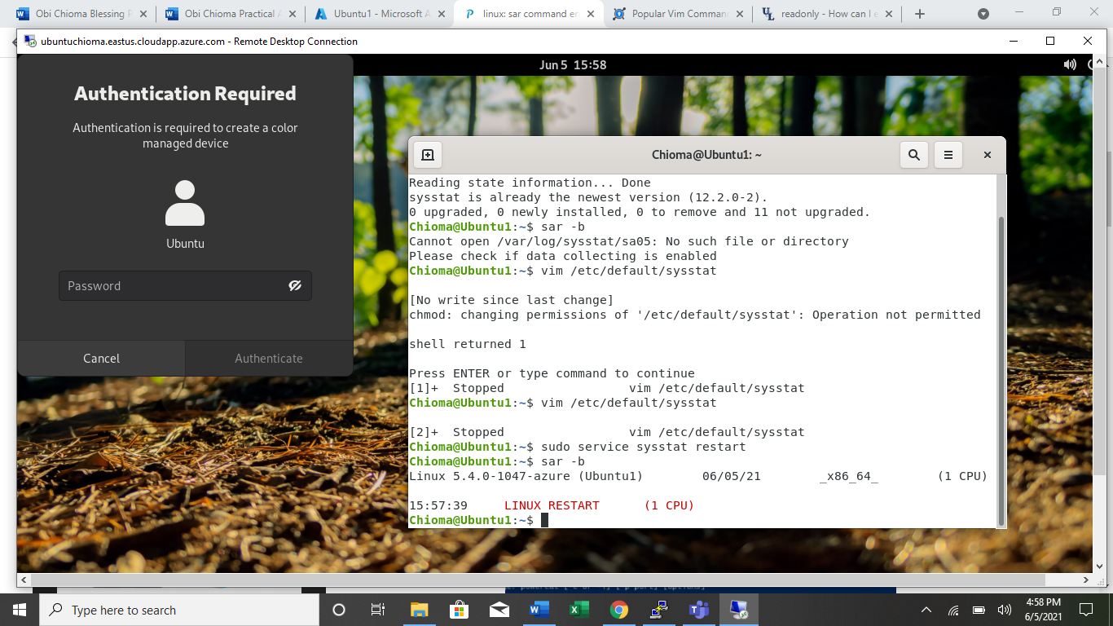

1. **Check Disk Activity statistics.**

I installed dstat using **sudo apt-get install dstat**, then run the command **dstat –d**  to check disk activity.

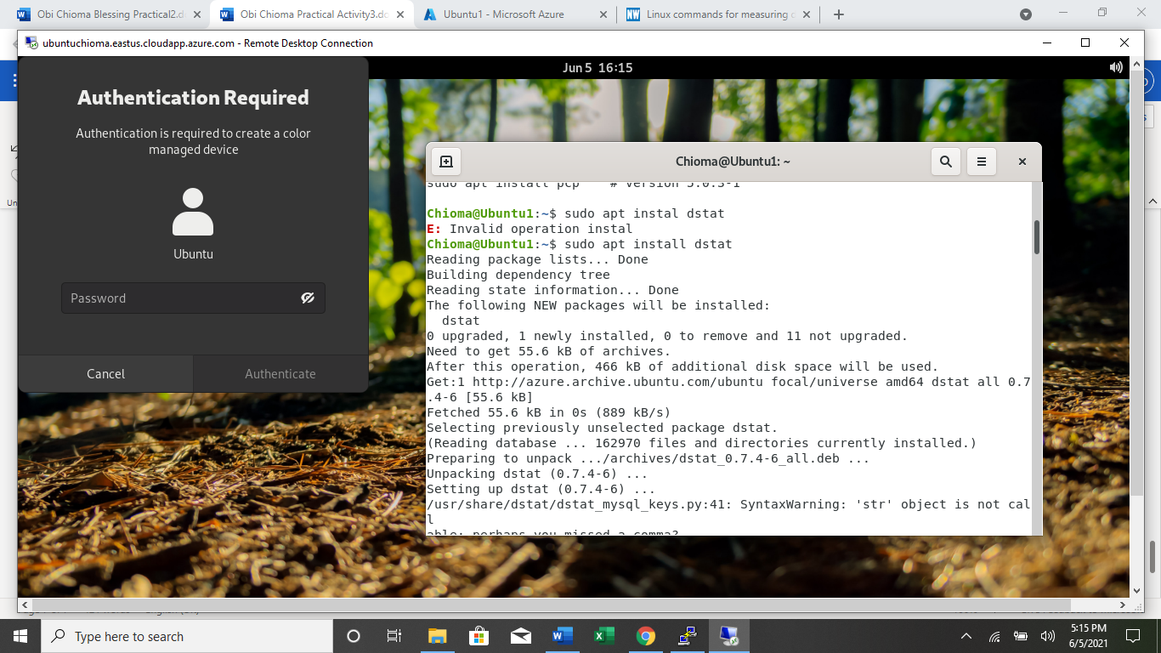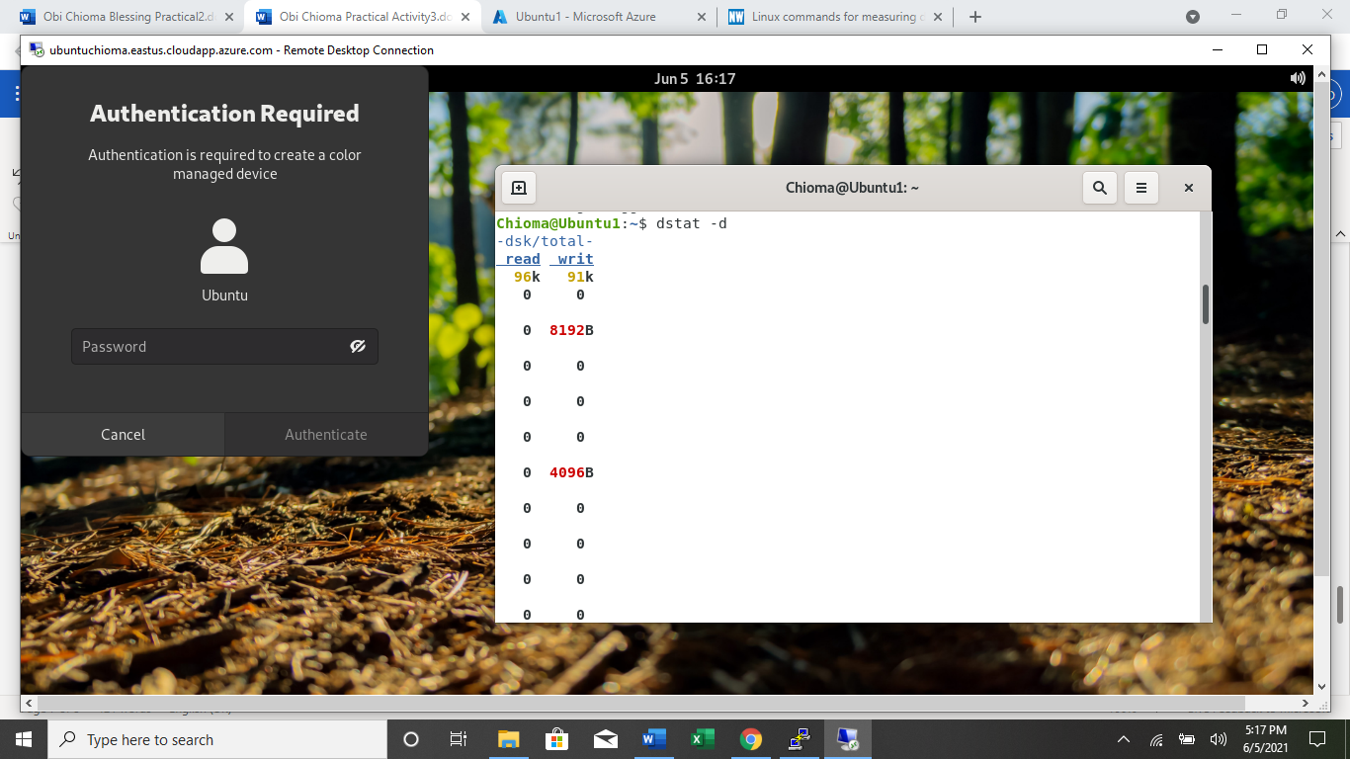

1. **Check Inter process Communication statistics.**

To check inter process communication. I used the command **ipcs**

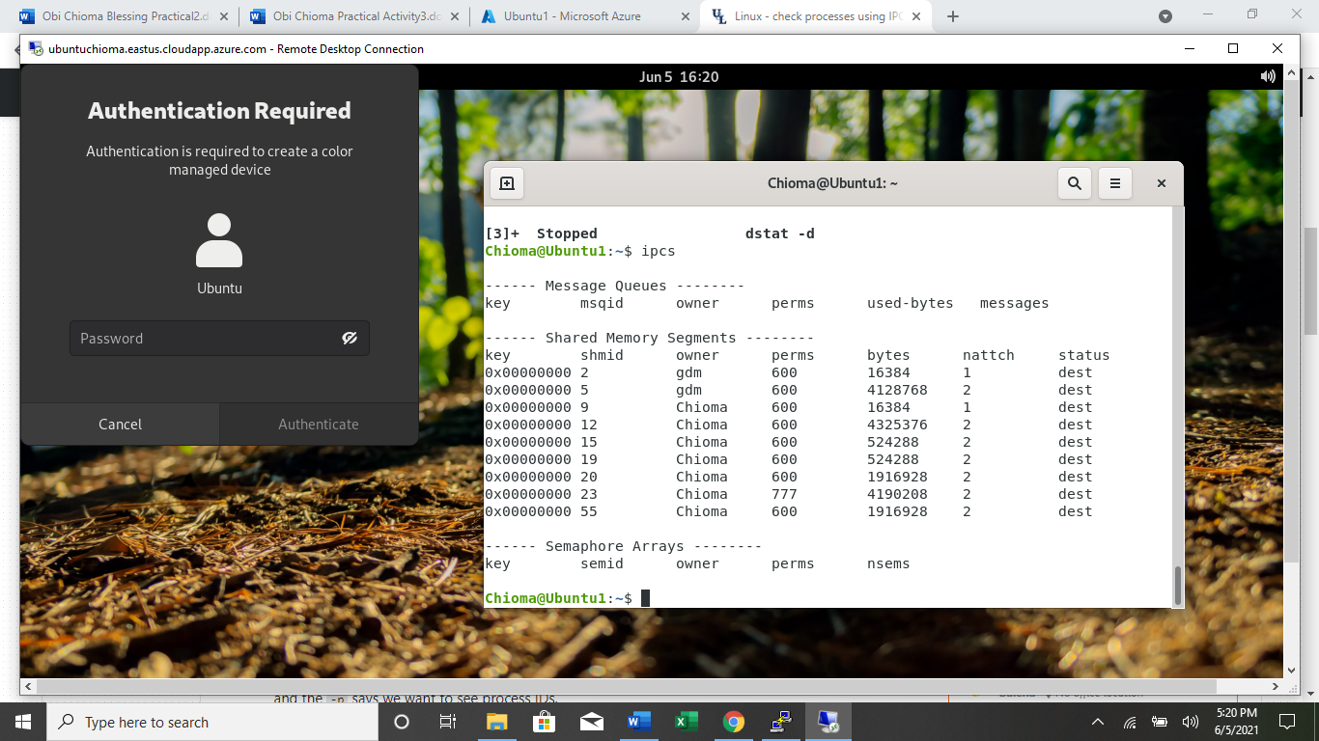

1. **Check Unused Memory in the server.**

I used the command **cat /proc/meminfo**

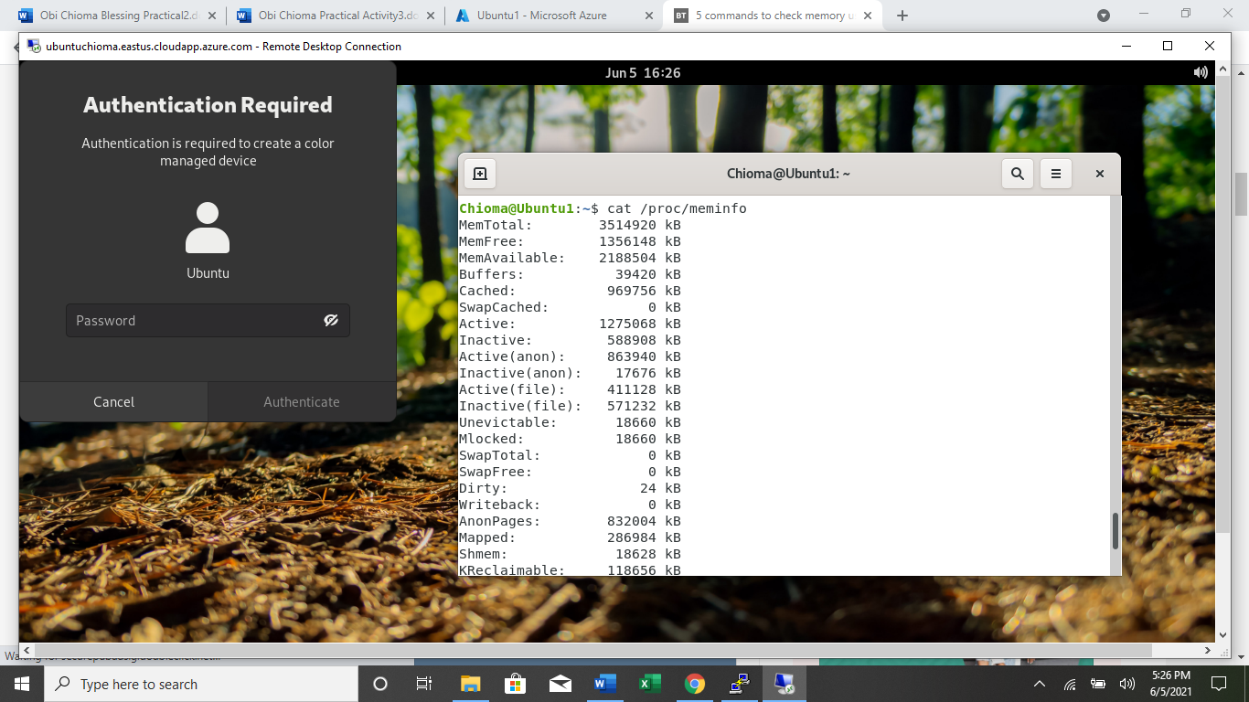

1. **Check Swap Activities.**

TO check the swap activities, I use the comman **sar -w**

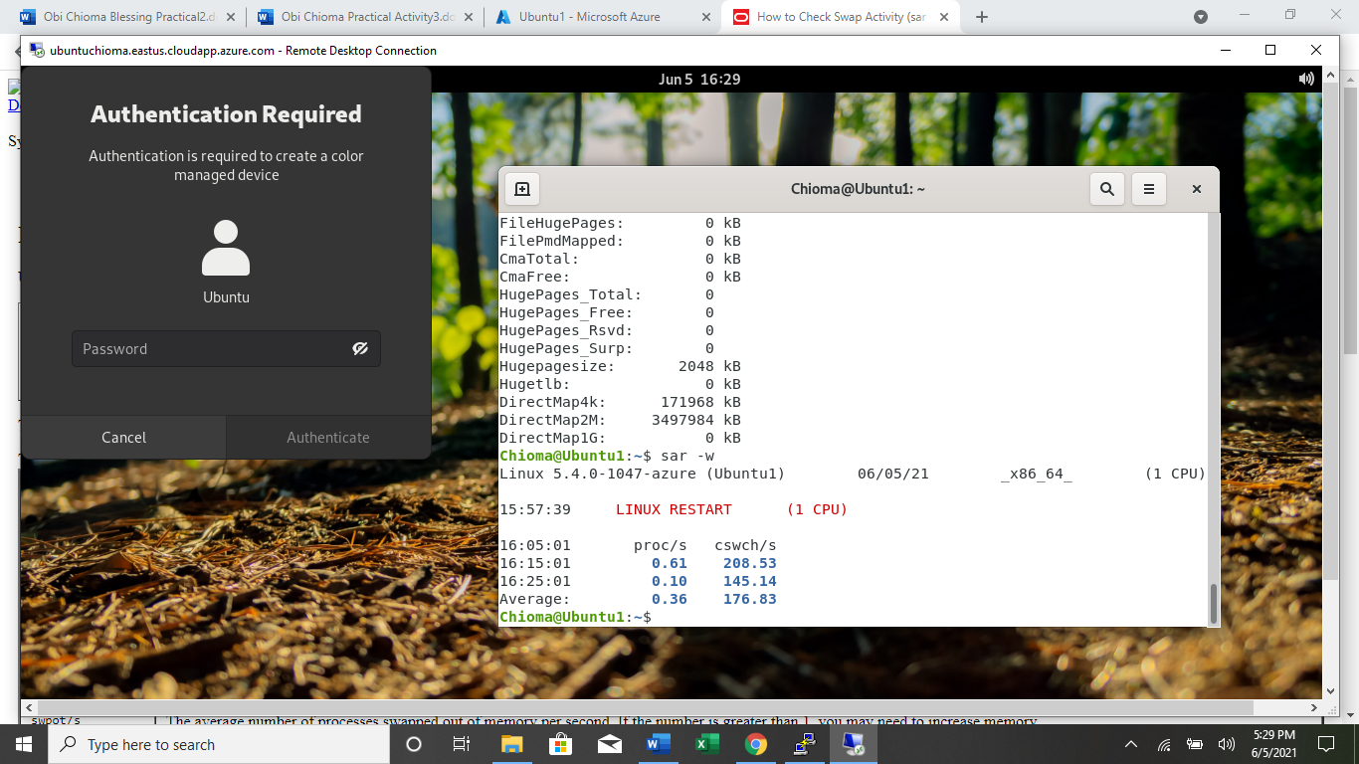

**Part 2 : Practical Activity Week 3**

1. **Create a user account called user1 and another user2**

To create user1, I used command **sudo adduser user1**

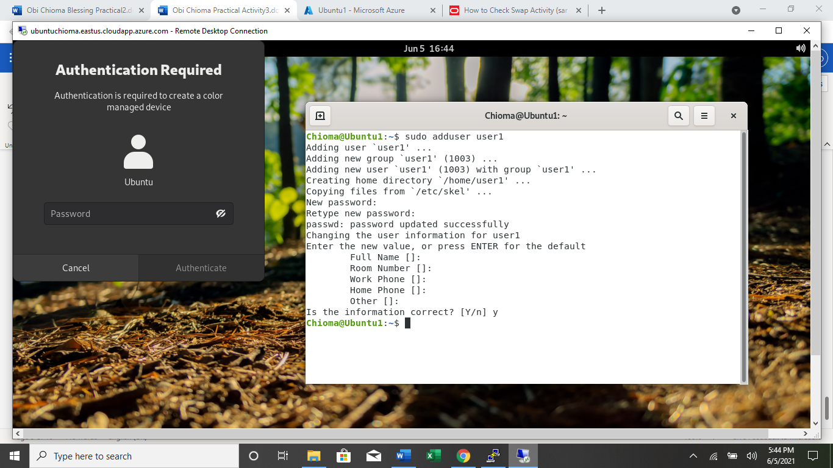

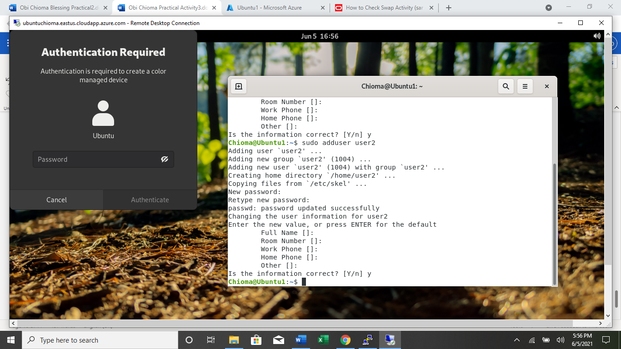

1. **Ensure user1 and user2 are password protected.**



1. **Logout and login as user1**

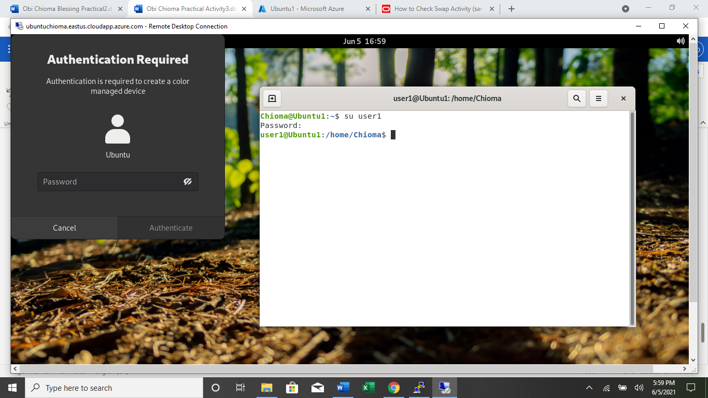

1. **Create a testdir**



1. **Create a file testfile in testdir**



1. **Verify the ownership and the group of the testfile**

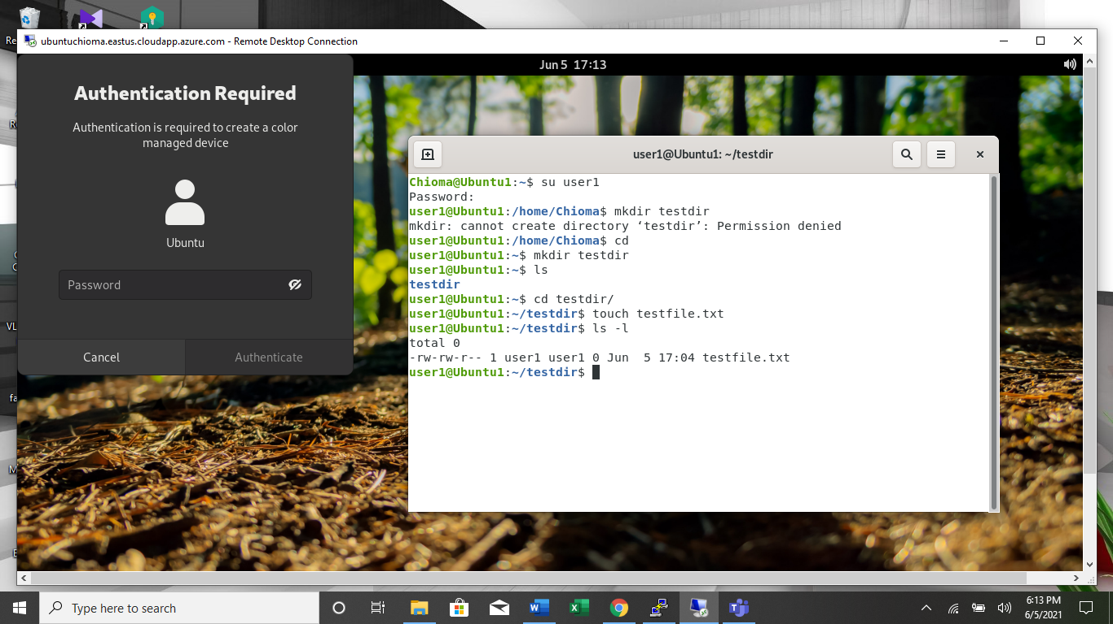

1. **Switch to Superuser account**



1. **Create a public directory dir1**

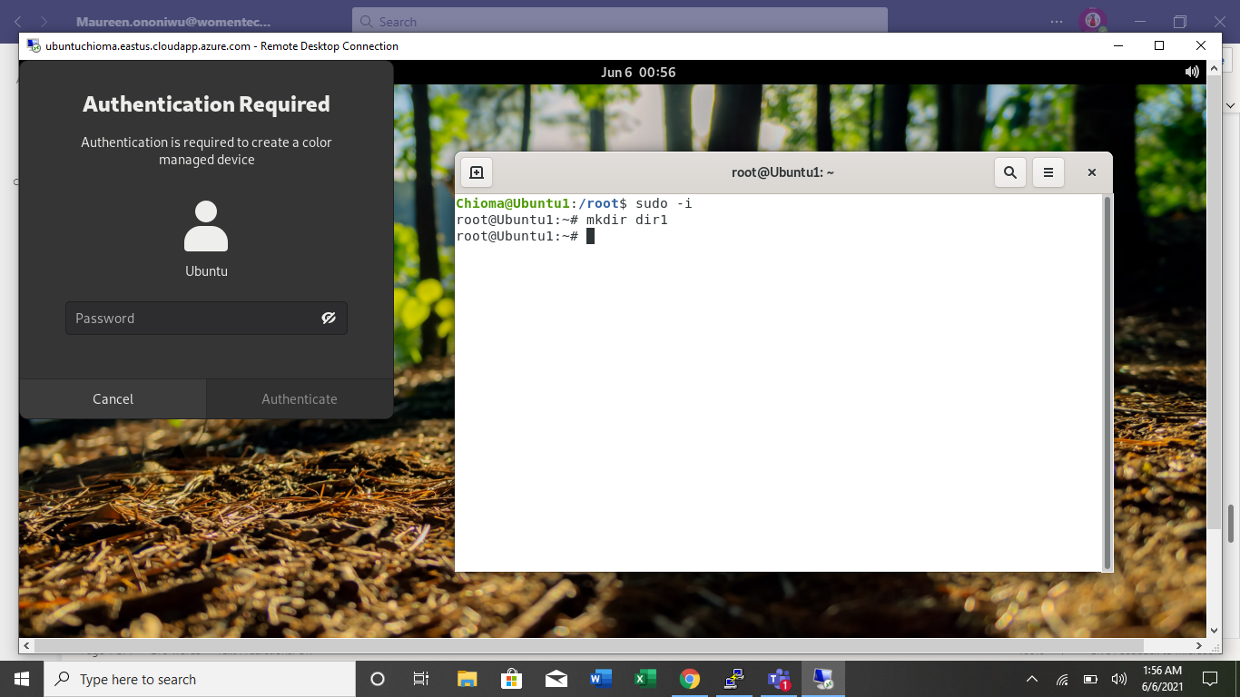

1. **Set stickybit (save text attribute) on dir1**

My ubuntu machine developed error, I tried to fix it for days by switching off and on, deleting and redeploying but it didn’t come up so I had to switch to my local virtual machine. This implies that the original user changed from **Chioma@ubuntu** to **blexcel@kali**

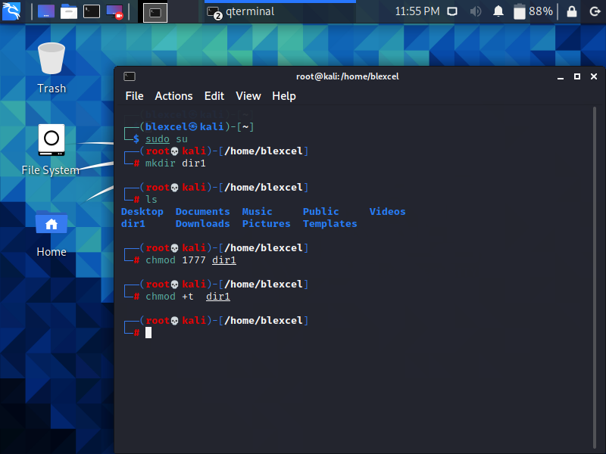

1. **Logout and login as a normal user user1**

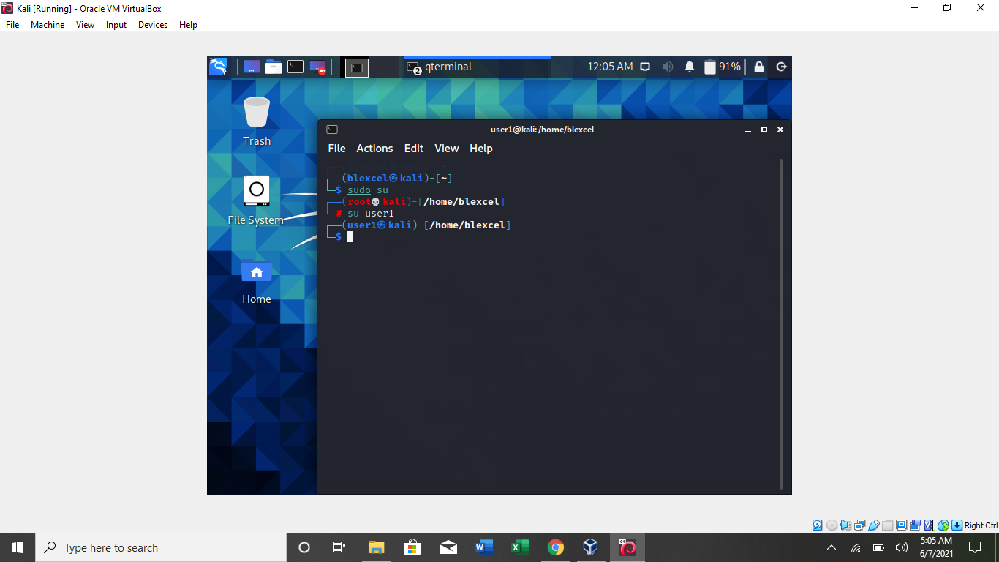

1. **Create a file userfile1 in dir1**

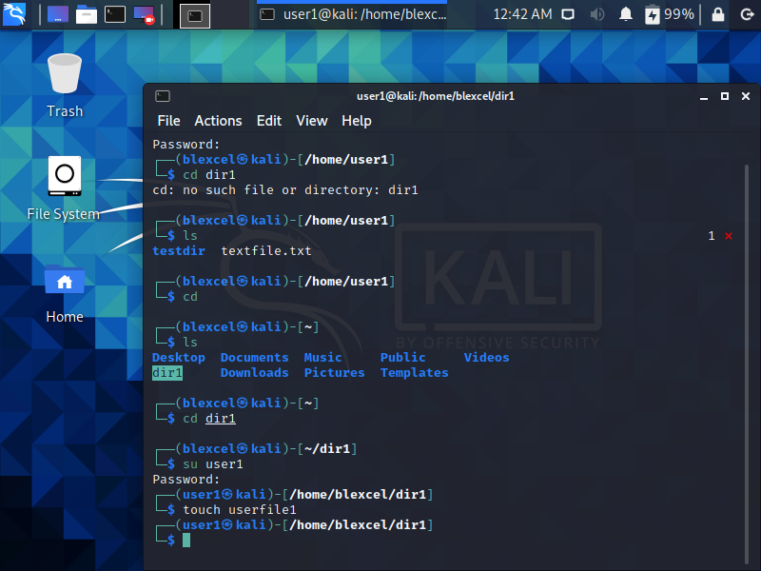

1. **Login as a different user user2**

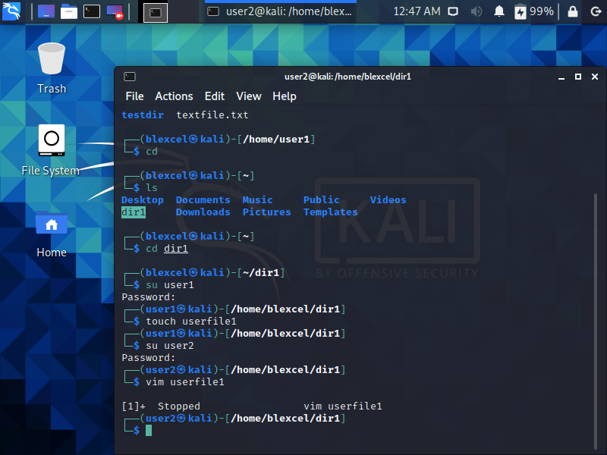

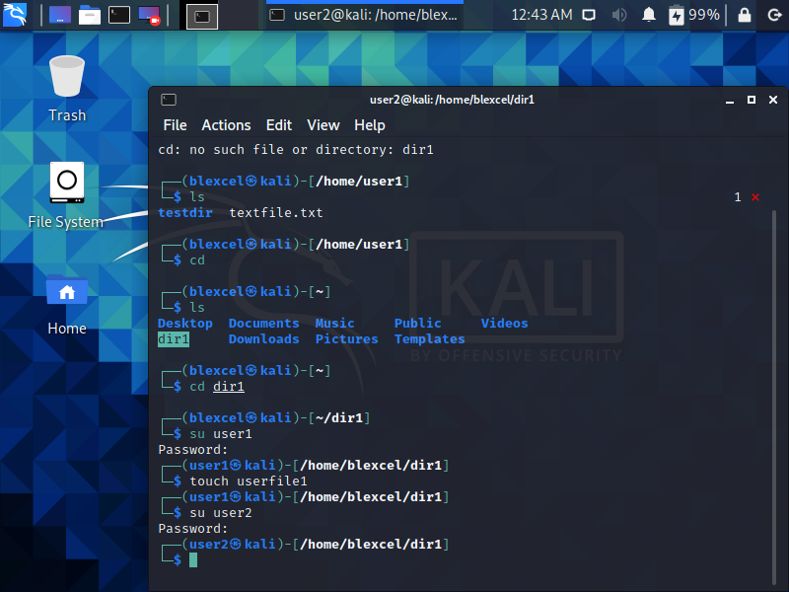

1. **Try to edit or remove the file**

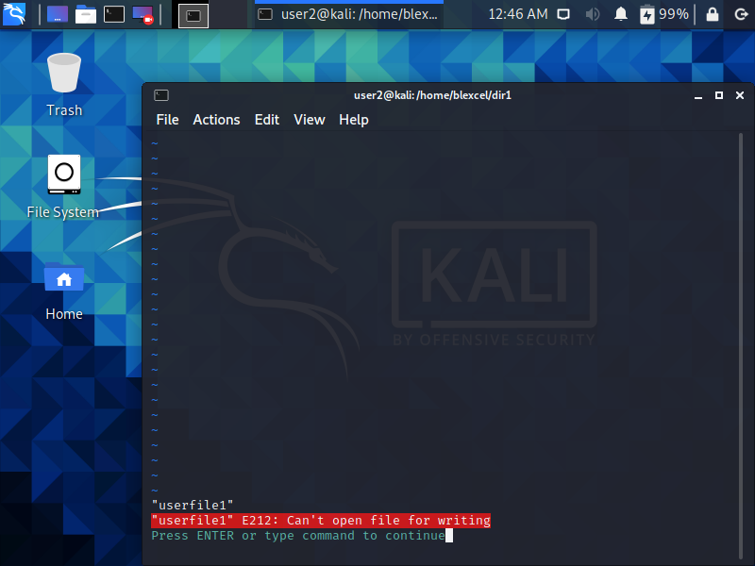

1. **Temporarily disable user logins**

